**Project Proposal Form**

Name of Candidate**: Chathura Prasan Suduwella**

Registration No.: **2015/MCS/073** Index No.: **15440731**

Email Address: [cpsuduwella@gmail.com](mailto:cpsuduwella@gmail.com) Contact No: **0718016083**

Title of Project: **Visual Light Communication for Location Based Wi-Fi Connectivity**

Image result for right markThis Project: New Project Repeat Project

1. **The Problem**

Existing Wi-Fi connectivity is available for everyone who are within the range and has the authentication key. Although secured authentication protocols has introduced to restrict the access to unauthorized people, control access to the actual demand has not achieved yet. Available Wi-Fi networks use RF for data transmission and due to its ability to penetrate through walls and objects it is impossible to implement location based restrictions using RF as the communication technology.

1. **Objective of Project**

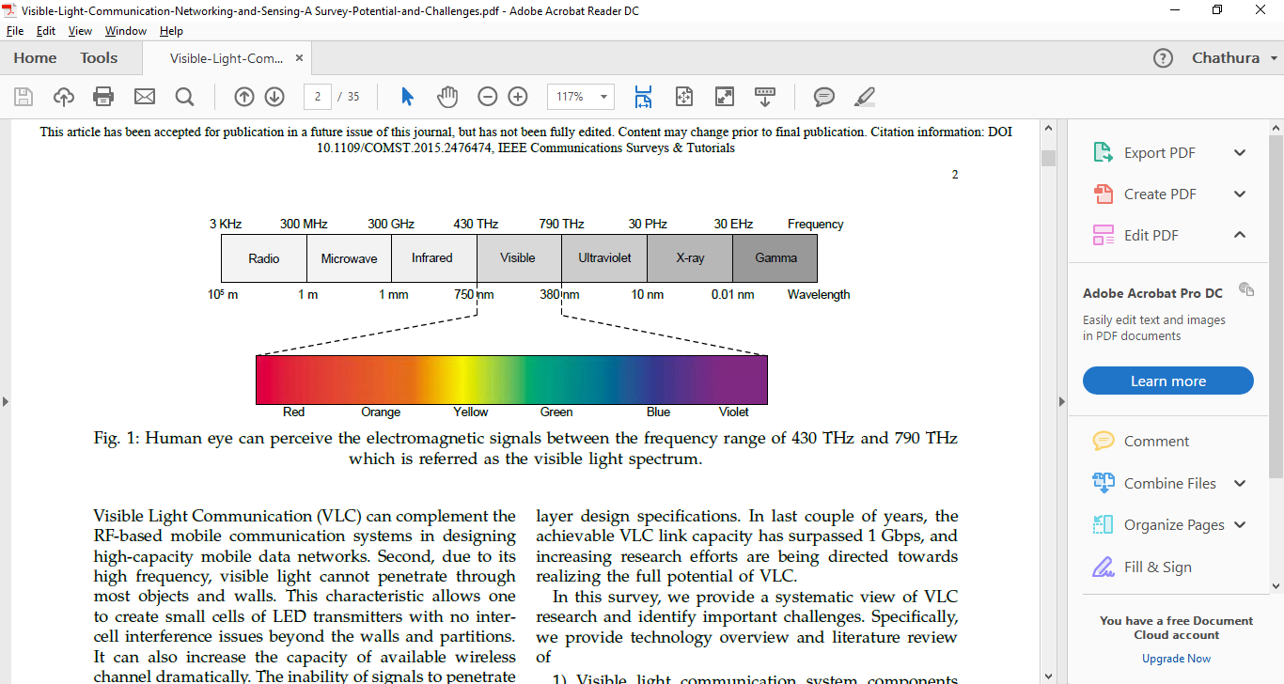Using emerging Visible Light Communication (VLC) technology I have propose dual channel authentication protocol where key distribution is done through the VLC thus network connectivity will restrict to the people in the location where LED which transmits the key exist. Visible Light is incapable of penetrating through walls and that feature has to used here for provide location based access to the wireless network. In addition we can visually isolate the LED visible area.

Fig. 1: Human eye can perceive the electromagnetic signals between the frequency range of 430 THz and 790 THz which is referred as the visible light spectrum.

1. **Related Projects**(Others who are proposing logically related work or previous projects which were based for your proposal)

In recent years with the bloom of the field of solid state lighting leads to the replacement of florescent lamps by Light Emitting Diodes (LEDs) which further motivates the usage of Visible Light for communication (VLC). Exponential growth in LED usage has been experienced which may have caused to open up researchers’ eye towards exploring methods to use already existing, widely available LED infrastructure to use as the communication medium which finally resulted in using visual light spectrum for data transfer[1]. Visible Light Communication or VLC is a novel communication method most researches have put faith on to become the communication technology of the next generation. It uses Light Emitting Diodes’ (LED) ability to switch into different intensity levels at a fast rate to transfer data[1-2]. LEDs will be the future of modern lighting system as they enjoy many advantages over conventional lighting devices. LED is known to be an efficient illumination source. In VLC technology in addition to illumination it also uses to send information using the same light signal. In literal terms any information that can be sent using a light signal that can be visible to human eye is considered to be VLC but most importantly light should be visible to humans but not the data we transfer through it.

The opportunity to send data usefully in this manner has largely arisen and under research because of the widespread use of LED light bulbs. We can switch LEDs at very high speed that were not possible with older light sources such as fluorescent and incandescent lamps. The adaptation of LED light bulbs during last few years has created a massive opportunity for VLC. The problems of congestion of the radio spectrum utilized by Wi-Fi is also helping to the improvement of VLC. The Radio Frequency (RF) communication suffers from high latency and interference issues and also it requires a separate setup for transmission and reception of RF waves. Overcoming the above mentioned issues VLC can be used as a preferred communication technique because of its high bandwidth and immunity to interference from electromagnetic sources.

The world has moved to use wireless technology decades ago replacing the wired technologies available for Internet connectivity. Wi-Fi is the name of a popular wireless networking technology that uses radio waves to provide wireless high-speed Internet and network connections with devices based on the IEEE 802.11 standards [3]. Still Wi-Fi is the widely used wireless technology for connect to the global Internet. In Wi-Fi when an RF current is supplied to an antenna, an electromagnetic field is created that then is able to propagate through space. The main component of a wireless network is a device known as an Access Point (AP). The primary job of an access point is to broadcast a wireless signal that computers can detect and "tune" into. That is the main problem we have identified in the available Wi-Fi technology. When establishing a Wi-Fi connection there is a 3 step process for connecting to an AP or wireless router where authentication happens. Same RF is used to share the secret key in the existing Wi-Fi technology. Thus if the Wi-Fi has not given open access, users who are connecting need to provide user name and password to authenticate at least once. But the problem here is anyone within the range of the Wi-Fi can get access once they have authenticated once and if not forget.

Through this paper we are proposing a novel protocol for location dependent Internet connectivity using VLC based authentication. This dual channel authentication protocol mainly depends on VLC to share the secret key for user authentication and once authenticated available Wi-Fi technology can be used to connect to the Internet. Our main target is to provide location based Internet access which will ultimately result in more restricted access to Wi-Fi where more sensitive and confidential data transfer is required. The available Wi-Fi access points use password authentication but anyone within the range of the access point and have the password can get access. But using this novel protocol we can restrict the access to a single indoor location or a room. One of the secondary goals of the proposed protocol is to use the existing infrastructure to achieve minimum implementation cost.

[1] D. Tsonev, S. Videv, and H. Haas, “Light fidelity (Li-Fi): towards all-optical networking,” 2013, vol. 9007, pp. 900702-900702–10.

[2] L. U. Khan, “Visible light communication: Applications, architecture, standardization and research challenges,” *Digit. Commun. Netw.*

[3] “Wi-Fi,” *Wikipedia*. 21-Mar-2017.

[4] Pathak, Parth H., et al. "Visible light communication, networking, and sensing: A survey, potential and challenges." *ieee communications surveys & tutorials* 17.4 (2015): 2047-2077.

1. **Scope of Project**

Project is mainly focus on to cover location based authentication using VLC.

1. **Is this Project Work Related?** (if Yes, Please indicate clearly your planned contribution)

No

1. **Client / Customer for the Project** (If applicable)

No

1. **List of Deliverables** (All deliverables should be presented at the end of project and any deviation should be justified)

VLC enable network connected LED bulb, VLC data receiver, working prototype

1. **Work Breakdown Structure (**A Gantt Chart should be included**)**

|  |  |  |  |  |  |  |  |  |  |  |  |  |
| --- | --- | --- | --- | --- | --- | --- | --- | --- | --- | --- | --- | --- |
| **Task** | **2017** | | | | | | | | **2018** | | | |
| May | Jun | Jul | Aug | Sep | Oct | Nov | Dec | Jan | Feb | Mar | Apr |
| Study VLC, electronics, Wi-Fi authentication methods |  |  |  |  |  |  |  |  |  |  |  |  |
|  |  |  |  |  |  |  |  |  |  |  |  |
|  |  |  |  |  |  |  |  |  |  |  |  |
| Build VLC capable LED bulb |  |  |  |  |  |  |  |  |  |  |  |  |
|  |  |  |  |  |  |  |  |  |  |  |  |
|  |  |  |  |  |  |  |  |  |  |  |  |
| Write VLC data transmission and communication code |  |  |  |  |  |  |  |  |  |  |  |  |
|  |  |  |  |  |  |  |  |  |  |  |  |
|  |  |  |  |  |  |  |  |  |  |  |  |
| Define receiving method and create necessary electronics and write data decoder |  |  |  |  |  |  |  |  |  |  |  |  |
|  |  |  |  |  |  |  |  |  |  |  |  |
|  |  |  |  |  |  |  |  |  |  |  |  |
| Define and configure Wi-Fi authentication protocol for testing AP |  |  |  |  |  |  |  |  |  |  |  |  |
|  |  |  |  |  |  |  |  |  |  |  |  |
|  |  |  |  |  |  |  |  |  |  |  |  |
| Write AP authentication module for VLC |  |  |  |  |  |  |  |  |  |  |  |  |
|  |  |  |  |  |  |  |  |  |  |  |  |
|  |  |  |  |  |  |  |  |  |  |  |  |
| Testing altogether |  |  |  |  |  |  |  |  |  |  |  |  |
|  |  |  |  |  |  |  |  |  |  |  |  |
|  |  |  |  |  |  |  |  |  |  |  |  |

1. **Additional Information**

**…………………………………**

**Signature of candidate** **Date: 20/05/2017**

1. **Details of Project Supervisor**(s):

|  |  |  |
| --- | --- | --- |
|  | ***Supervisor (USCS Staff Member)*** | ***Advisor (Can be outside of UCSC_)*** |
| **Name** | Dr. Kasun De Zoysa |  |
| **Designation** | Senior Lecture |  |
| **Comment**  (To be filled by the supervisor/ Advisor) |  |  |
| **Supervisor’s / Advisor’s Signature** | ***…………………………………….***  *Date:* | ***…………………………………****.*  *Date:* |

********